CRYPTO CURRENCY MARKET ANALYSIS DASHBOARD USING EXCEL

- Name – Ishita Das
- Date – 10.06.26
- Role – Data Analyst Intern
- Organization Name – ElevanceSkills Technology Pvt Ltd

1. INTRODUCTION
This project focuses on cryptocurrency market analysis using Microsoft Excel dashboards and analytical techniques. The project was developed using real-time cryptocurrency data collected from CoinMarketCap through Python web scraping using libraries such as BeautifulSoup, requests and pandas.
The objective of the project is to analyze crypto market trends, compare coins based on market performance, identify investment insights and create interactive dashboards for data-driven decision-making.
The dashboards include KPI indicators, slicers, pivot tables, dynamic charts, liquidity analysis, historical price analysis, and investment insights. The project demonstrates practical skills in data preprocessing, Excel analytics, dashboard design, visualization and business intelligence reporting.

2. BACKGROUND
The cryptocurrency dataset was collected using Python web scraping from CoinMarketCap. Around 200–300 cryptocurrency records were extracted including coin name, symbol, price, market capitalization, trading volume, circulating supply, and percentage changes over multiple time periods.
The collected cryptocurrency dataset was cleaned and transformed before analysis. Currency symbols were removed, numerical values were standardized, helper columns were created for calculations, and price ranges were categorized to support dashboard filtering and KPI analysis.
3. LEARNING OBJECTIVES
• Understand cryptocurrency market analytics
• Develop interactive Excel dashboards
• Perform data cleaning and preprocessing
• Apply pivot tables, slicers, KPI cards, and charts
• Improve analytical and visualization skills

4. ACTIVITIES AND TASKS
TASK 1 — MAIN CRYPTO DASHBOARD
An interactive cryptocurrency market dashboard was created using pivot tables, slicers, KPI cards, and charts to analyze overall market performance. The dashboard provided insights into cryptocurrency prices, trading volume, market capitalization, and circulating supply while enabling dynamic filtering and comparison of crypto assets.

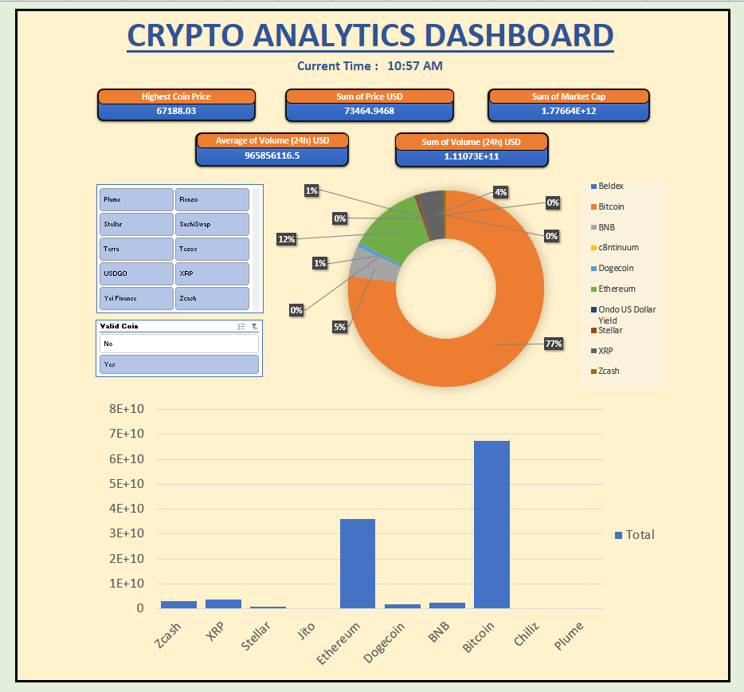
TASK 2 — COIN COMPARISON DASHBOARD
A comparison dashboard was developed to compare two cryptocurrencies side-by-side using important market indicators such as symbol, price, market capitalization, trading volume, and circulating supply. KPI cards and conditional formatting were used to highlight the differences between selected coins dynamically.

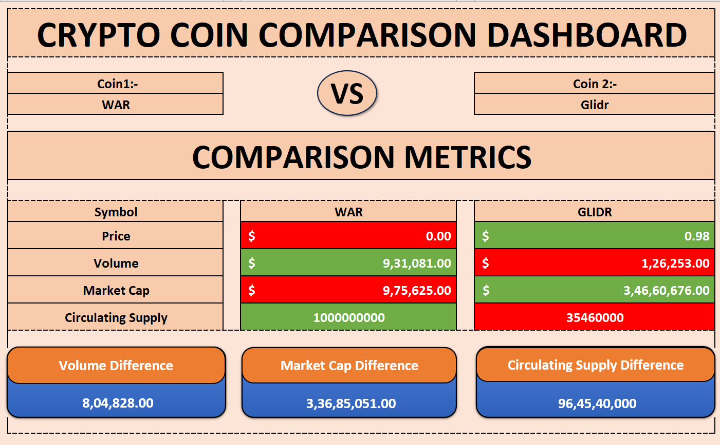

TASK 3 — TOP 5 LIQUIDITY ANALYSIS
A liquidity analysis dashboard was created to visualize the distribution of cryptocurrency trading volume using a doughnut chart. The dashboard displayed the top 5 cryptocurrencies based on 24-hour trading volume and grouped remaining coins under an “Others” category. Interactive slicers enabled filtering based on price ranges.
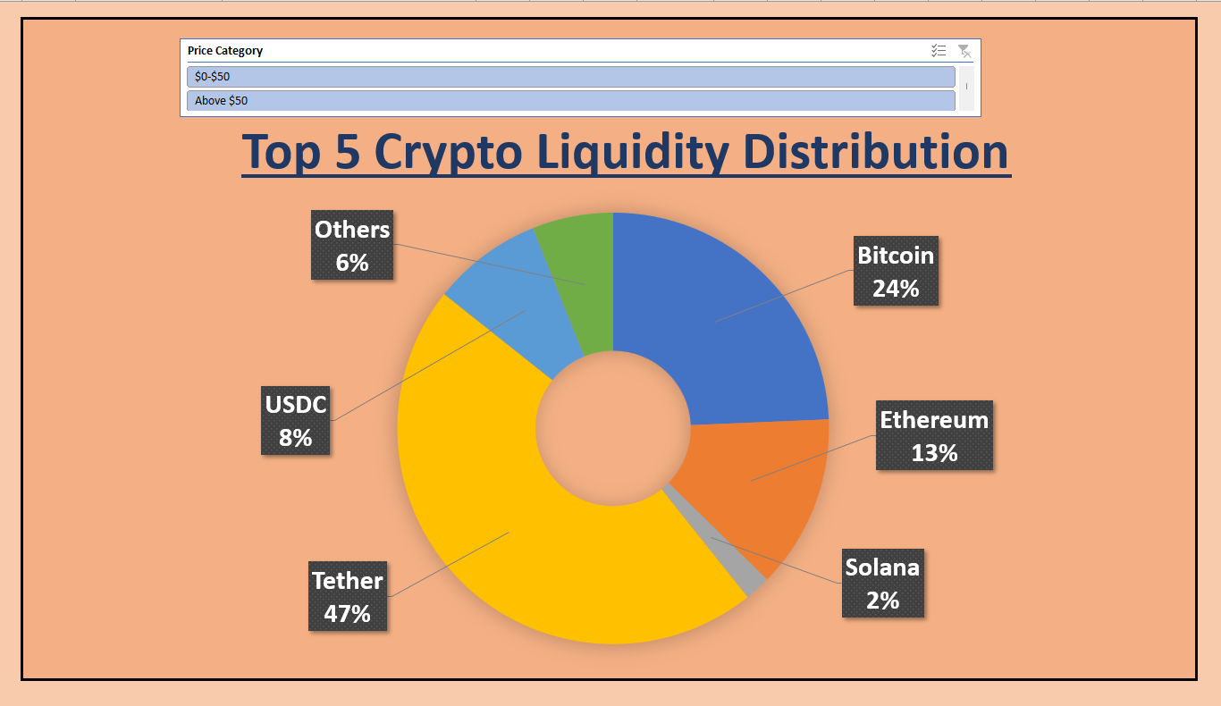

TASK 4 — PRICE CHANGE COMPARISON ANALYSIS
This dashboard analyzed cryptocurrency price movement by comparing current prices with estimated previous prices using 1-hour percentage changes. Interactive charts and slicers were used to display the top-performing cryptocurrencies and provide insights into short-term market trends.

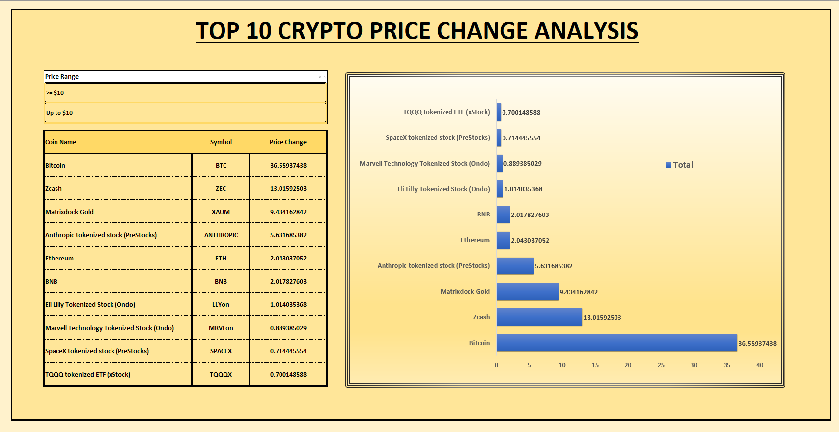
TASK 5 — HISTORICAL PRICE CHANGE INSIGHTS
A historical trend analysis dashboard was created using 1-hour, 24-hour, and 7-day percentage changes to estimate historical price movement. The dashboard compared 24-hour and 7-day prices for the top 10 cryptocurrencies ranked by 1-hour price change within the selected price range.

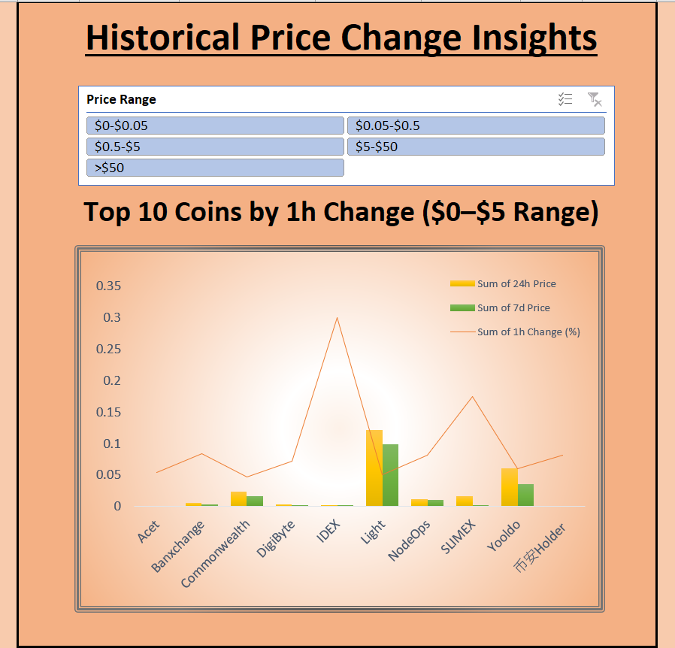

TASK 6 — LOW BUDGET INVESTMENT INSIGHTS
A KPI-based investment insights dashboard was developed to identify cryptocurrencies with the least average downfall percentage across different price ranges. The dashboard included dynamic slicers, KPI cards, and stability analysis to help identify comparatively stable low-budget investment options.

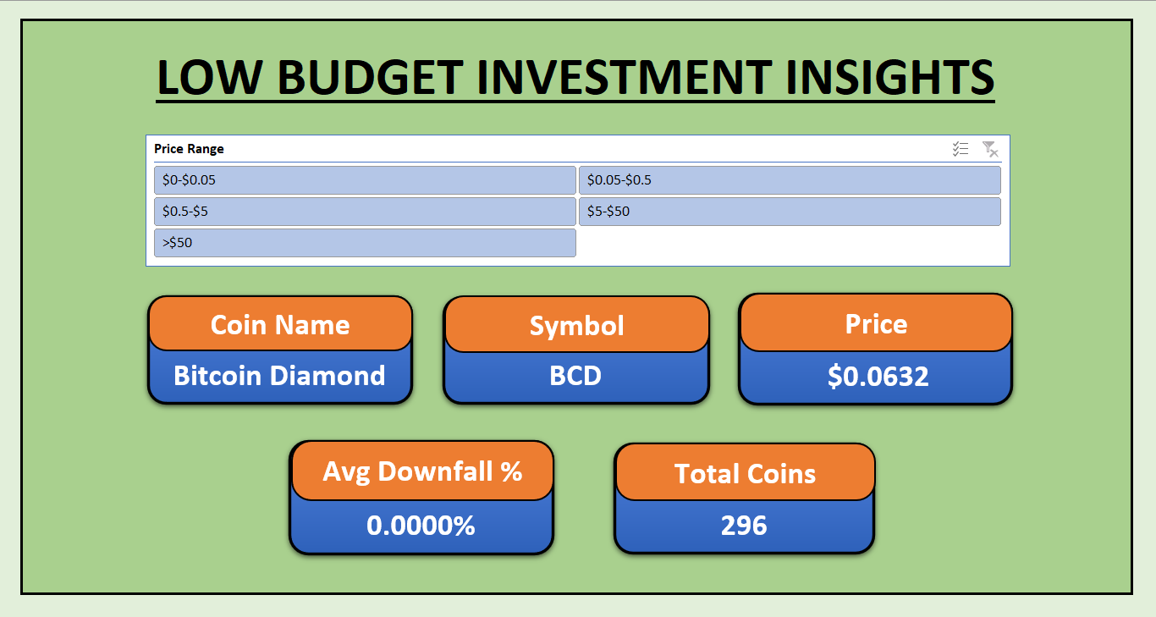

5. SKILLS AND COMPETENCIES
• Microsoft Excel Dashboard Development
• Data Visualization
• Pivot Tables and Pivot Charts
• KPI Analysis
• Python Web Scraping
• Data Cleaning and Transformation
• Business Intelligence Reporting
• Analytical Thinking

6. FEEDBACK AND EVIDENCE
The project dashboards successfully demonstrated interactive cryptocurrency market analysis using real-time data. Dashboard screenshots, KPI cards, slicers, charts, and GitHub repository evidence were included as proof of project completion and implementation.

7. CHALLENGES AND SOLUTIONS
Challenges Faced:
• Pivot refresh and slicer synchronization issues
• Dynamic KPI linking
• Conditional formatting issues
• Data preprocessing challenges
Solutions Implemented:
• Reconnected slicers using report connections
• Used helper columns and formulas for KPI calculations
• Applied dynamic pivot filtering techniques
• Standardized numerical data for accurate analysis

8. OUTCOMES AND IMPACT
The project helped improve practical understanding of cryptocurrency analytics, dashboard development, and data visualization. Interactive dashboards enabled efficient market analysis, investment insights, and comparative crypto performance evaluation.

9. CONCLUSION
This project successfully demonstrates cryptocurrency market analysis using Excel dashboards and Python-based data collection techniques. Interactive dashboards, KPI tracking, comparative analysis, and trend visualization helped transform raw crypto market data into meaningful business insights.
The project improved analytical thinking, dashboard development, visualization skills, and practical understanding of financial data analytics.

